42.20: 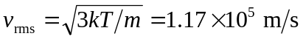, as found in Example 42.9. The equipartition theorem does not hold for the electrons at the Fermi energy. Although these electrons are very energetic, they cannot lose energy, unlike electrons in a free electron gas.

